Implementation (Validation)

Project Name
CSV File Upload and Processing System

Validation 1: File Type Validation

Class
UploadDocumentService.java

Method
uploadDocuments()

Description
Before storing the uploaded file, the application checks whether the uploaded file has a .csv extension. If the uploaded file is not a CSV file, the application throws a runtime exception and rejects the upload.

Code Screenshot

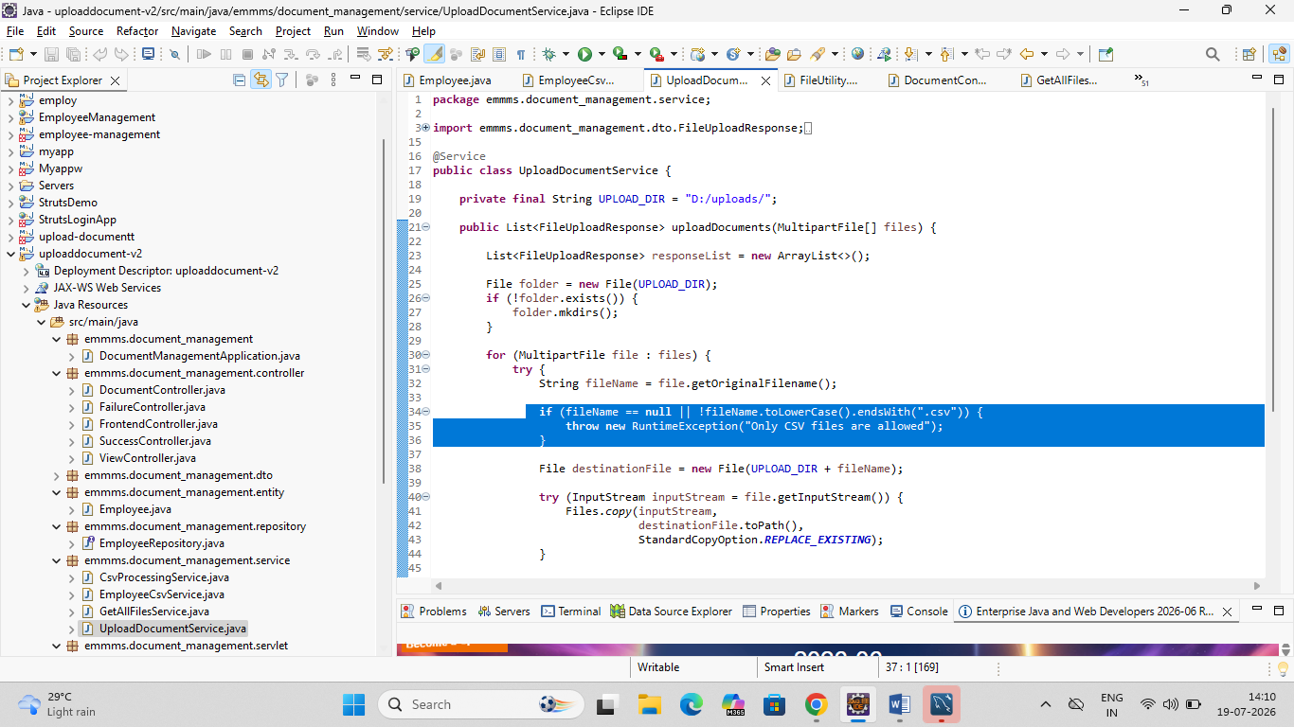Expected Result
- CSV files are accepted.
- Files with other extensions are rejected.

Validation 2: CSV Header Validation

Class
FileProcessingScheduler.java

Method
validateCsv(File file)

Description
The application validates the header of the uploaded CSV file. The expected header is:
id,name,email,salary
If the header does not match, the file is treated as invalid and moved to the Error folder.

Code Screenshot

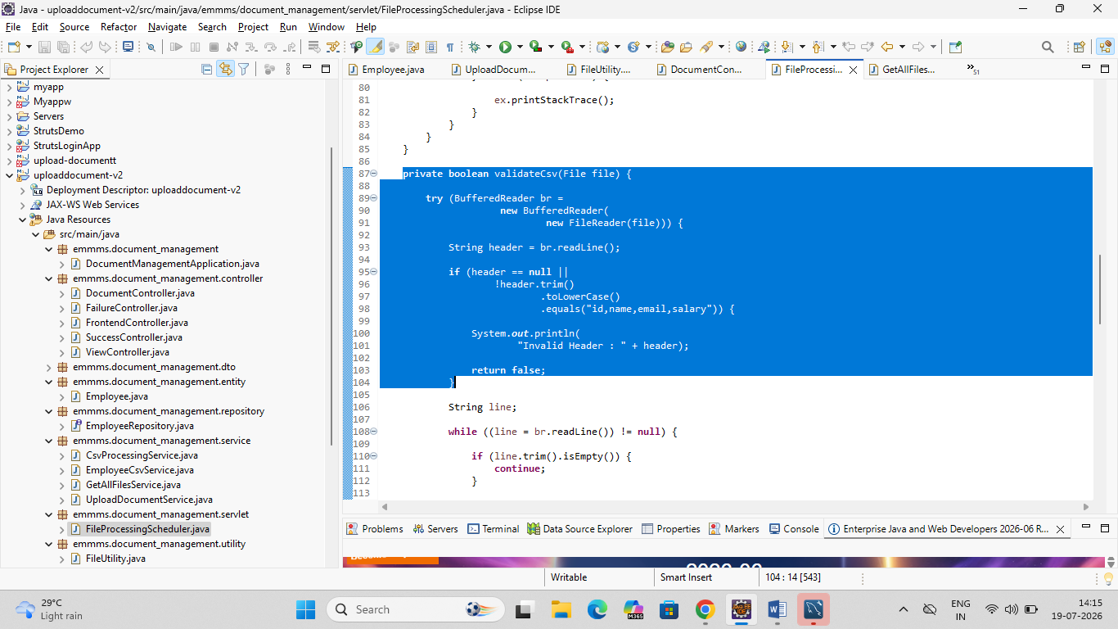Expected Result
- Correct header → File is processed.
- Incorrect header → File is moved to the Error folder.

Validation 3: Empty Row Validation

Class
FileProcessingScheduler.java

Method
validateCsv(File file)

Description
While reading the CSV file, the application ignores blank rows.

Code Screenshot

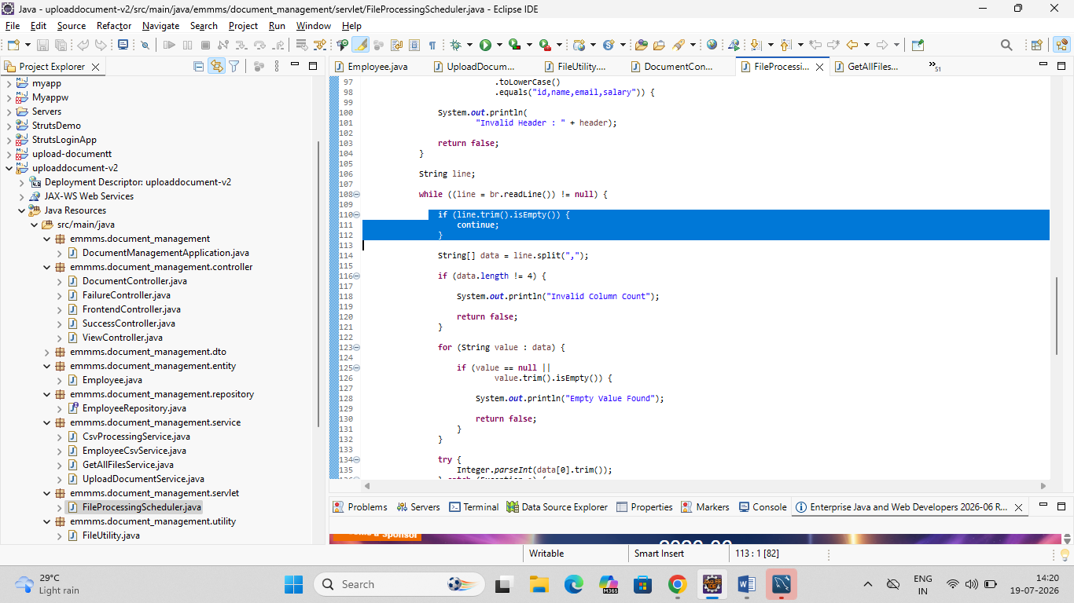Expected Result
- Empty rows are skipped during processing.

Validation 4: Column Count Validation

Class
FileProcessingScheduler.java

Method
validateCsv(File file)

Description
Each employee record must contain exactly four columns:
- ID
- Name
- Email
- Salary
If the number of columns is incorrect, the file is marked as invalid.

Code Screenshot

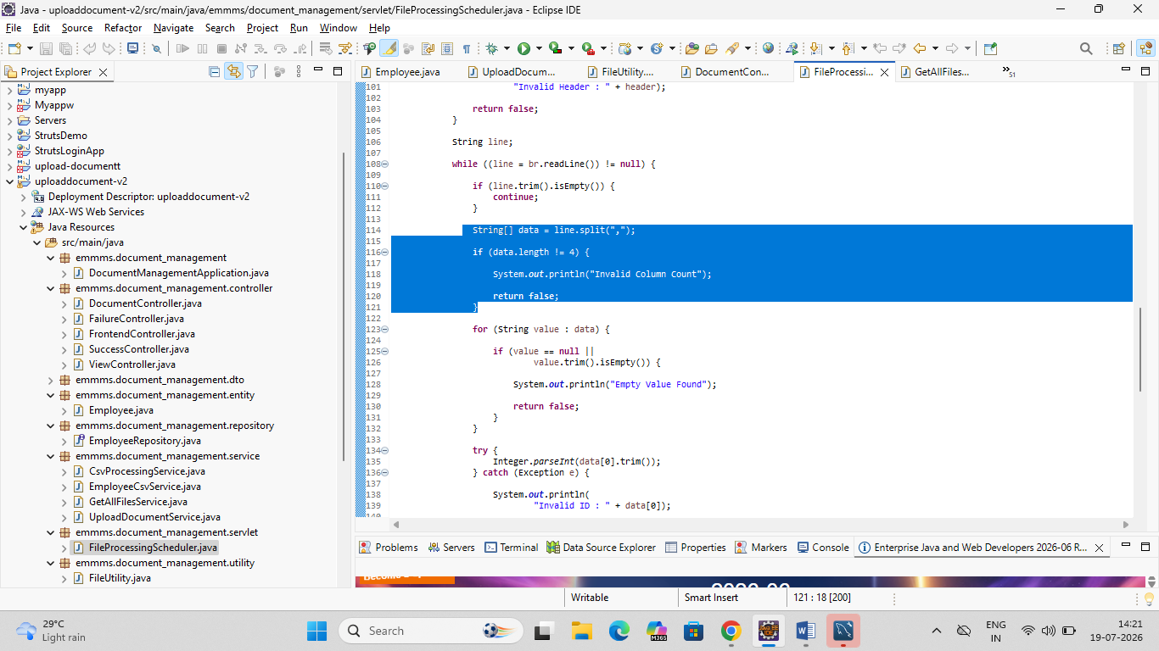Expected Result
- Valid records contain four columns.
- Invalid records are rejected.

Validation 5: Empty Field Validation

Class
FileProcessingScheduler.java

Method
validateCsv(File file)

Description
The application checks that none of the employee fields are empty.

Code Screenshot

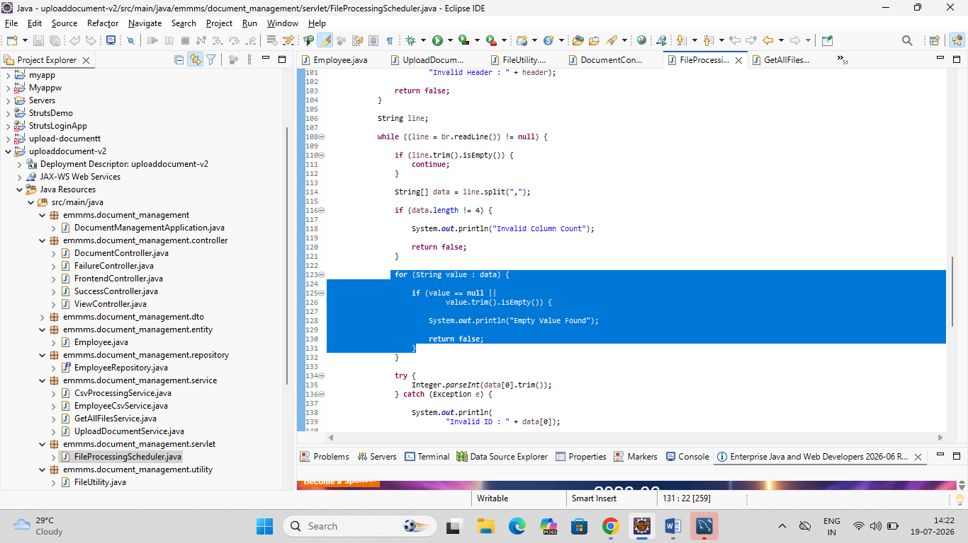Expected Result
- Records containing empty values are rejected.

Validation 6: Employee ID Validation

Class
FileProcessingScheduler.java

Method
validateCsv(File file)

Description
The application verifies that the Employee ID is numeric by converting it to an integer.

Code Screenshot

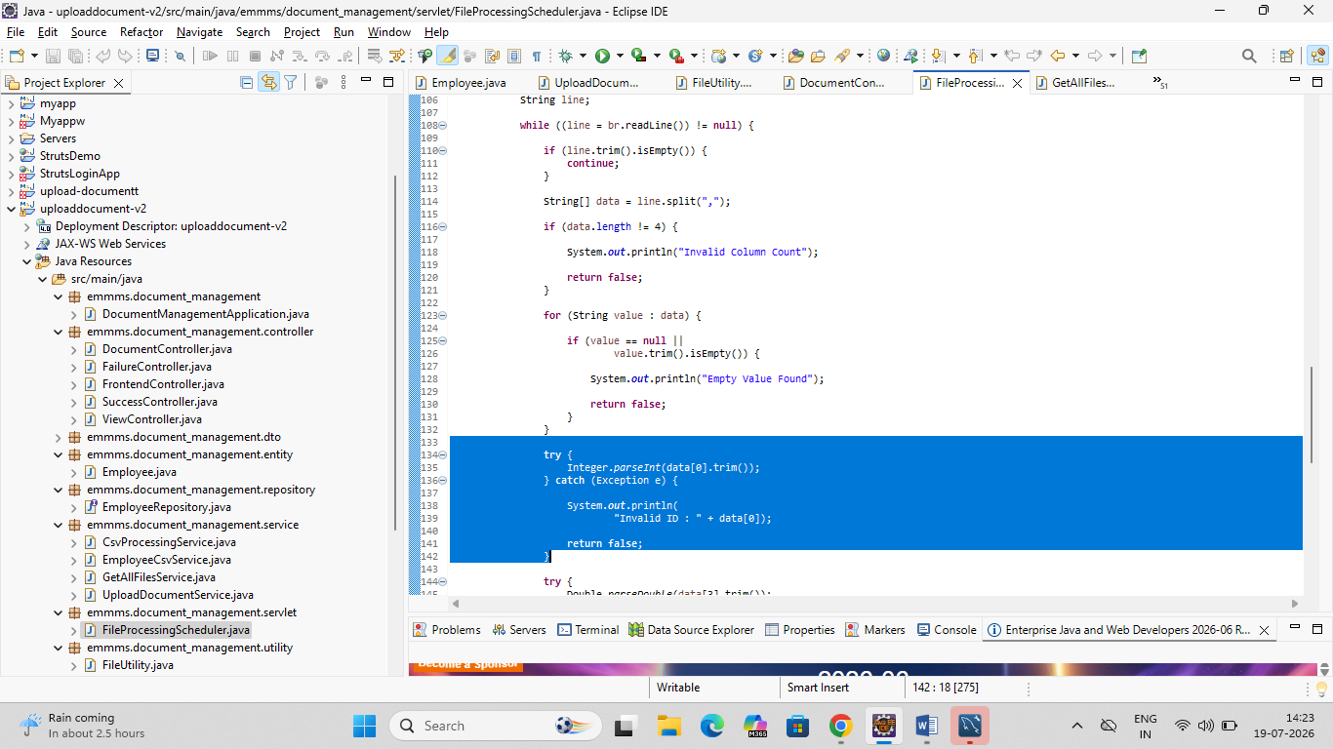Expected Result
- Numeric IDs are accepted.
- Non-numeric IDs are rejected.

Validation 7: Salary Validation

Class
FileProcessingScheduler.java

Method
validateCsv(File file)

Description
The application validates that the Salary field contains a numeric value.

Code Screenshot

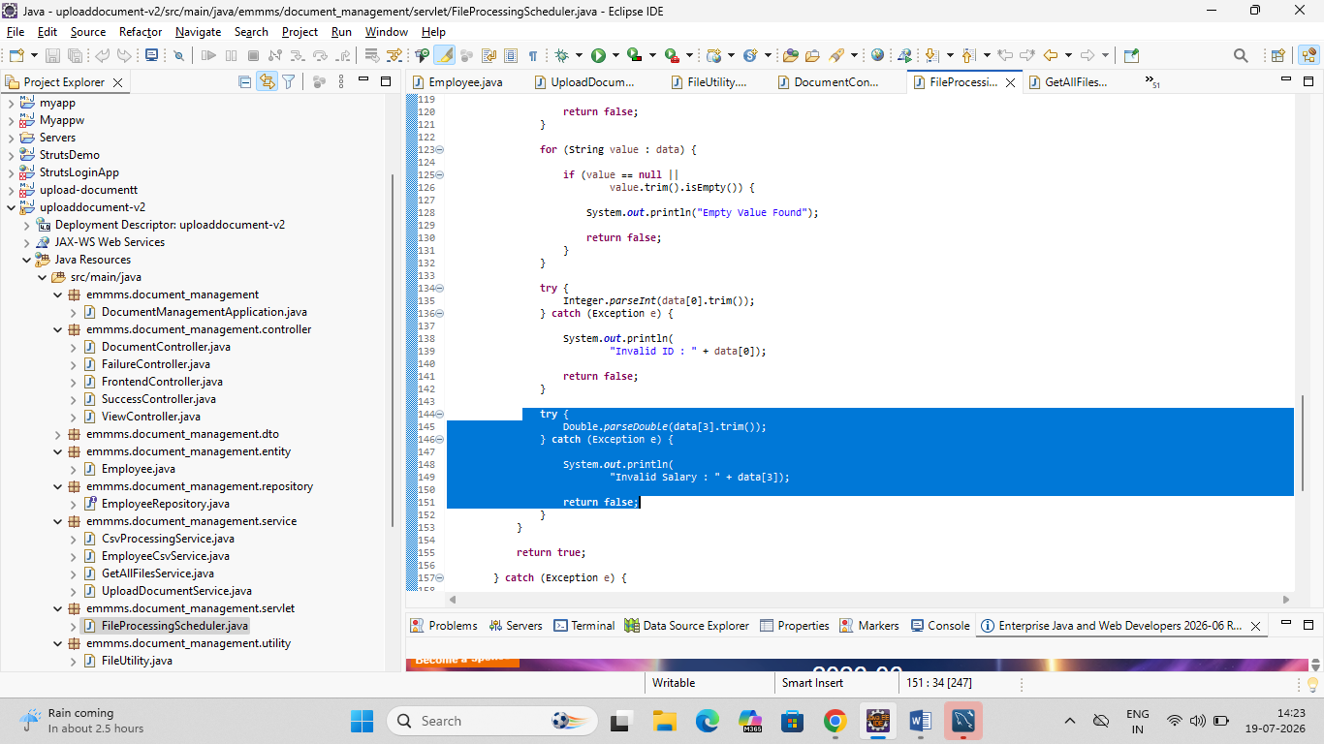Expected Result
- Numeric salary values are accepted.
- Invalid salary values are rejected.

Exception Handling

Class
FileProcessingScheduler.java

Description
If an exception occurs while processing a file, the application automatically moves the file to the Error folder.

Code Screenshot
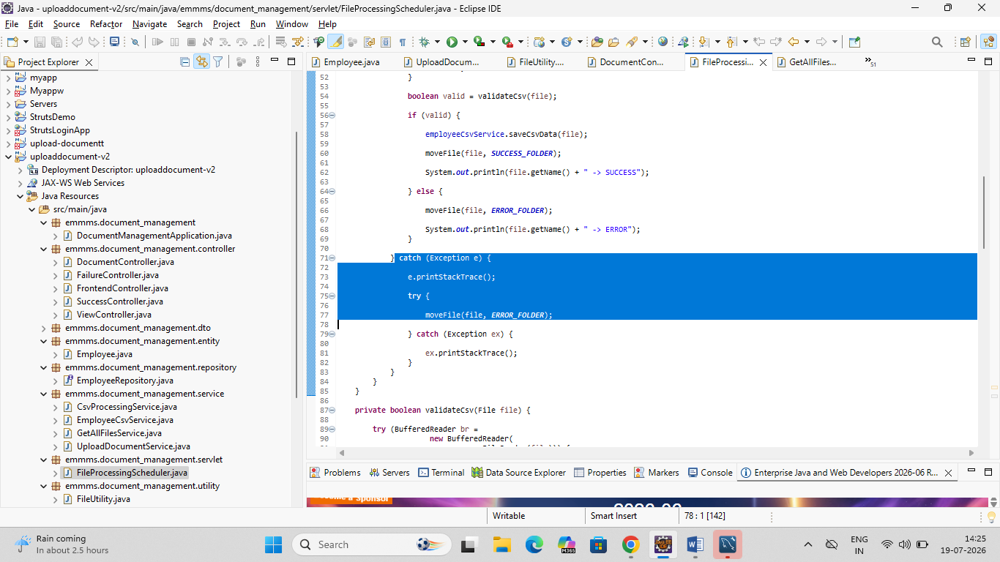

Validation Summary
Validation | Implemented
CSV File Validation | Yes
CSV Header Validation | Yes
Empty Row Validation | Yes
Column Count Validation | Yes
Empty Field Validation | Yes
Employee ID Numeric Validation | Yes
Salary Numeric Validation | Yes

Conclusion
The application validates uploaded CSV files before processing them. It checks the file type, CSV header, column count, empty fields, employee ID, and salary values. Valid files are processed and moved to the Success folder, while invalid files are moved to the Error folder.

